Expert Tips on Choosing the Right New Orleans Fence Company for Your Home

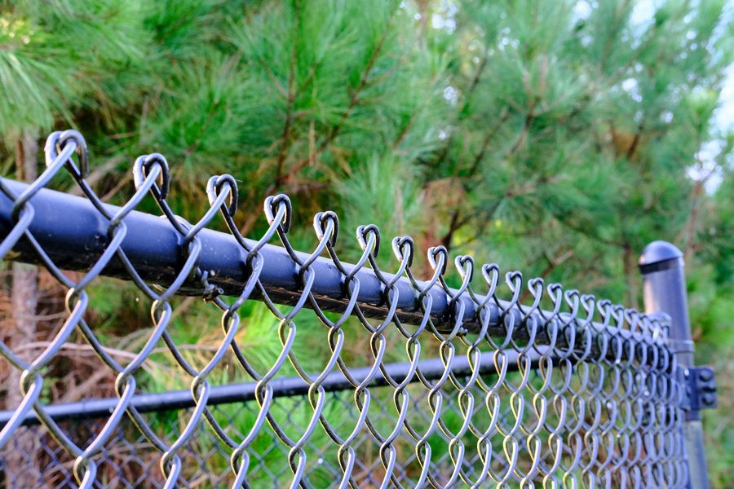

In New Orleans, the right fence can do wonders for your property’s appearance, security, and value. Many homeowners overlook the impact that high-quality fencing can have on the overall worth of their property. Whether you're looking to sell your home or simply want to enhance your living space, working with professional fence companies in New Orleans can provide long-term benefits that go beyond aesthetics. In this comprehensive guide, we explore how these companies can transform your property and why investing in fencing is an essential step in maximizing its value.

**The Role of Fencing in Boosting Property Value**

When it comes to increasing property value, first impressions matter. A well-installed fence can significantly improve curb appeal, making your home stand out from others on the block. Buyers are often drawn to properties that are not only attractive but also secure, private, and functional. By choosing the right fence for your property, you create an inviting environment that can elevate your home’s marketability.

A fence marks the boundary of your property, providing privacy and security for both the homeowner and their family. For families with children or pets, it’s an essential feature that offers peace of mind. Fencing can also reduce noise pollution, especially in urban areas like New Orleans, where streets can be bustling with activity. This combination of privacy, security, and functionality makes a professionally installed fence a valuable addition to any property.

**How New Orleans Fence Companies Enhance Your Property**

1. **Customization for Unique Needs**

New Orleans is a city with a rich and diverse architectural heritage. From historic homes in the French Quarter to modern suburban dwellings, each property has its own unique character. New Orleans fence companies understand the importance of tailoring fences to meet the specific needs of the property and the homeowner. They offer a wide variety of materials, styles, and designs to suit any taste, from classic wood and wrought iron to sleek aluminum or vinyl.

Custom-designed fences allow homeowners to complement their property’s aesthetic while ensuring that their security and privacy needs are met. A tailored fence can blend seamlessly into the existing landscape, enhancing the property’s overall appearance and making it more attractive to potential buyers.

1. **High-Quality Materials for Long-Lasting Value**

Investing in a high-quality fence made from durable materials is key to boosting your property value. New Orleans fence companies offer a selection of materials that are not only visually appealing but also built to withstand the harsh elements of the region. Whether it’s the humid climate, heavy rains, or occasional storms, a quality fence will stand the test of time and maintain its integrity for years to come.

Wood, for example, is a traditional favorite that adds charm and warmth to any property. Pressure-treated wood and cedar fences, when installed correctly, are resistant to rot, termites, and weather damage. Similarly, wrought iron fences are an excellent choice for homeowners looking for a classic, elegant look that also offers durability and security. Vinyl and aluminum are low-maintenance alternatives that are resistant to rust, fading, and corrosion, making them perfect for coastal regions like New Orleans.

1. **Enhanced Privacy and Security**

One of the primary functions of a fence is to provide privacy and security, which are highly sought after by potential buyers. A well-designed fence can shield your property from prying eyes and offer a sense of seclusion, which is especially important in densely populated areas like New Orleans.

Privacy fences made from solid materials such as wood or vinyl are particularly popular in areas where homeowners value their personal space. Fences that are tall and feature minimal gaps provide a barrier from street traffic and neighboring properties, creating a sanctuary for residents. Additionally, a sturdy fence is an effective deterrent against intruders, providing peace of mind for homeowners who are concerned about safety.

1. **Increased Curb Appeal**

Curb appeal plays a crucial role in the overall value of a property. Homes with attractive exteriors are more likely to sell faster and for a higher price. A professionally installed fence can enhance your property’s curb appeal by adding structure and definition to the landscape. It can also complement other design elements, such as landscaping, gates, and walkways.

Whether you choose a sleek, contemporary fence or a rustic, country-style design, the right fence can make a significant impact on how your home is perceived. Many fence companies in New Orleans also offer decorative elements such as custom gates, post caps, and finials that further elevate the visual appeal of your fence and, by extension, your entire property.

**Factors to Consider When Choosing a Fence for Your Property**

While the benefits of fencing are clear, it’s essential to choose the right type of fence for your property. Here are some important factors to consider when selecting a fence:

* **Purpose**: What is the primary reason for installing a fence? Are you looking for privacy, security, or simply an aesthetic upgrade? Understanding your needs will help determine the best type of fence for your home.
* **Material**: The material you choose for your fence will directly impact its longevity, maintenance requirements, and overall appearance. Consider factors such as the local climate, the level of maintenance you’re willing to commit to, and your budget.
* **Height and Design**: Fences come in various heights and designs. A taller fence may be more suitable for privacy, while a shorter, decorative fence may be ideal for aesthetic purposes. It’s important to strike the right balance between functionality and style.
* **Local Regulations**: Before installing a fence, check with local authorities to ensure that you comply with zoning laws, property line regulations, and any other restrictions. A professional fence company can assist you in navigating these requirements.

**Why Hiring Professional Fence Companies in New Orleans Makes a Difference**

While DIY fencing projects may seem appealing, hiring professional fence companies in New Orleans ensures that your fence is installed correctly and efficiently. Experienced fence contractors have the expertise to handle all aspects of the installation process, from choosing the right materials to securing permits and ensuring compliance with local regulations.

In addition to proper installation, professional fence companies offer valuable insights on maintenance and care to ensure that your fence continues to add value to your property for years to come. They are also equipped with the tools and knowledge needed to handle challenging terrain, such as sloped or uneven ground, which can make installation difficult for inexperienced individuals.

**Conclusion: The Impact of Fencing on Property Value in New Orleans**

In New Orleans, where charm, character, and security are highly valued, a professionally installed fence can significantly enhance your property’s appeal and value. By working with a trusted fence company, you gain access to customized solutions that fit your specific needs and budget. Whether you’re seeking to improve your home’s privacy, security, or curb appeal, the right fence can make a world of difference.

By choosing durable materials, unique designs, and professional installation, you not only invest in your property’s appearance but also in its long-term value. Don’t overlook the impact a quality fence can have—contact a New Orleans fence company today to explore the many ways a fence can transform your property and boost its market value.